Grade Checker
Take a score as input and print the grade based on the following:
90+ : "A"
80-89 : "B"
70-79 : "C"
60-69 : "D"
Below 60 : "F"
here we used a basic if else statement to carry out marks and all.
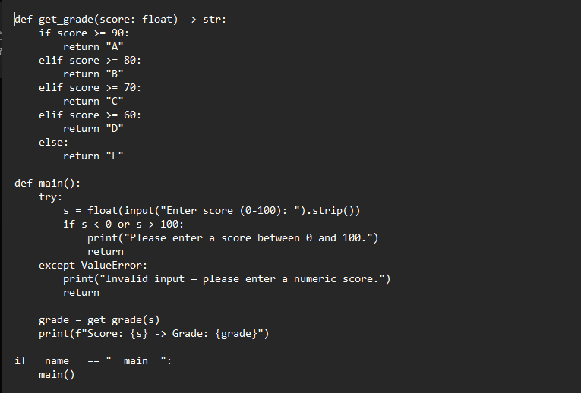
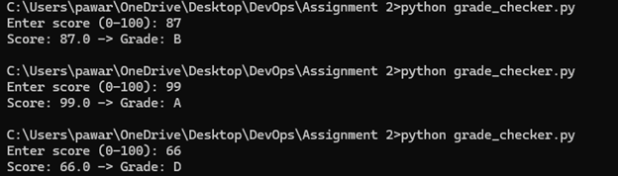

2 Student Grades
Create a dictionary where the keys are student names and the values are their grades. Allow the user to:
Add a new student and grade.
Update an existing student’s grade.
Print all student grades.
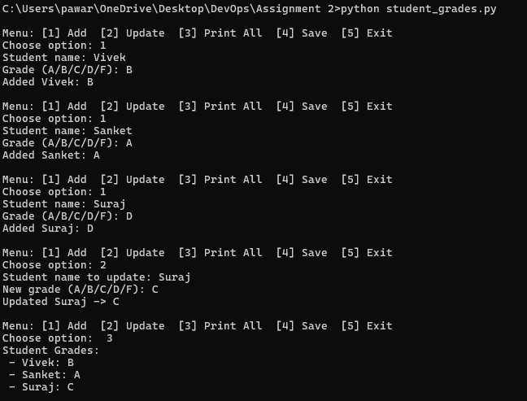

3.Write to a File
Write a program to create a text file and write some content to it.
4. Read from a File
We used open in read mode and file.read to read and print to display.

def main():
filename = "output.txt"
content = """Hello!
This is a sample file created by write_file.py.
You can replace this with any content you want.
"""

# Write content
with open(filename, "w") as f:
f.write(content)

# Read content
with open(filename, "r") as f:
print("File content:")
print(f.read())

if __name__ == "__main__":
main()
